WDC Group Project Milestone 1

## Researching Websites

**Website #1:** <https://umsu.unimelb.edu.au/buddy-up/clubs/>

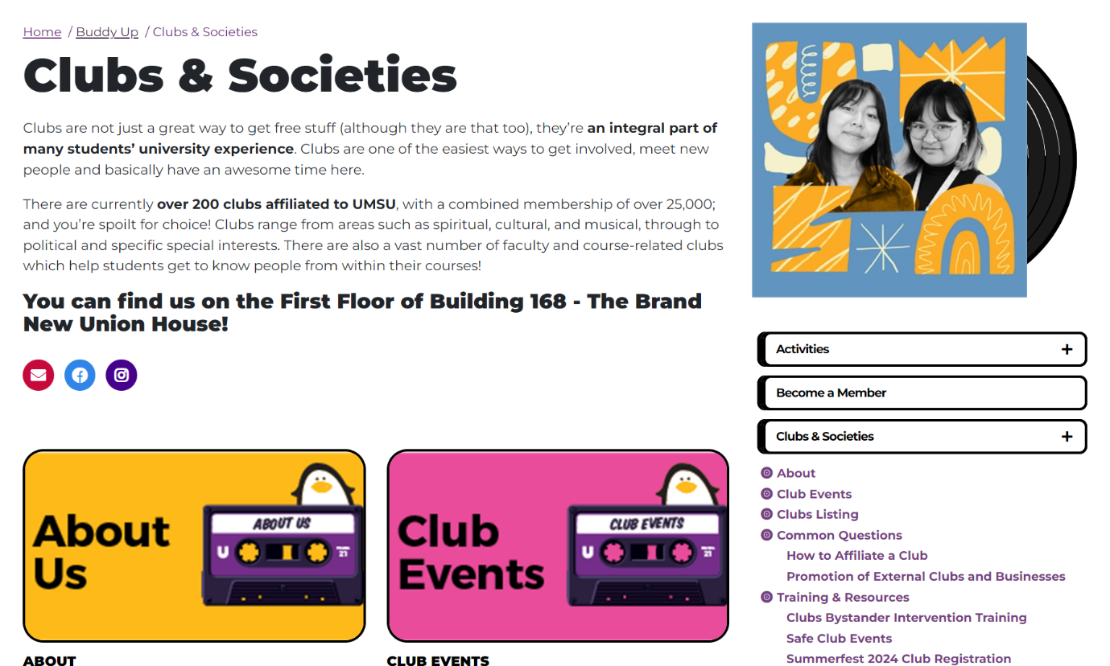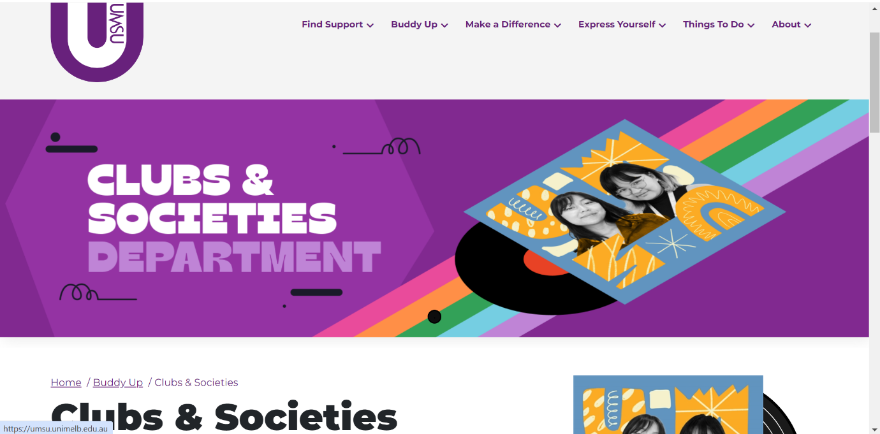The first website that was investigated was the University of Melbourne’s clubs and societies website.

**Parts that work well:**

* The website features a large colorful banner which instantly captivates the viewer’s attention.
* Websites use color effectively which reduces cognitive load and increases engagement.
* Important parts such as “over 200 clubs affiliated with UMSU” and where you can find the department are boldened. This is evident on multiple pages and is effective in making chunks of information more readable and digestible.
* Features an audio accessibility option, catered towards people with a vision impairment which in turn improves the experience for all users.
* It also uses colors with good contrast, and the text is clear, a good font has high contrast ratio (mostly black on a white background) and is a reasonable size, most of the time.
* Zooming in on the website to make the font size bigger does not break the website, the layout stays consistent.
* The website features input assistance to help users avoid mistakes and when filling in a form, notifies the user that not all fields have been filled in.
* The website also uses multiple Sans-serif fonts for optimal readability.

**Parts that don’t work well (See Screenshots Below)**

* People tend to have an F-shaped style to reading content on websites, the side menu is not well positioned to accommodate for this.
* Side menu is cluttered, which makes it a bit overwhelming and confusing for people to navigate through.
* Some pages on the website have irregular spacing, and text is way too cramped, which increases cognitive load and makes the website less perceivable.
* 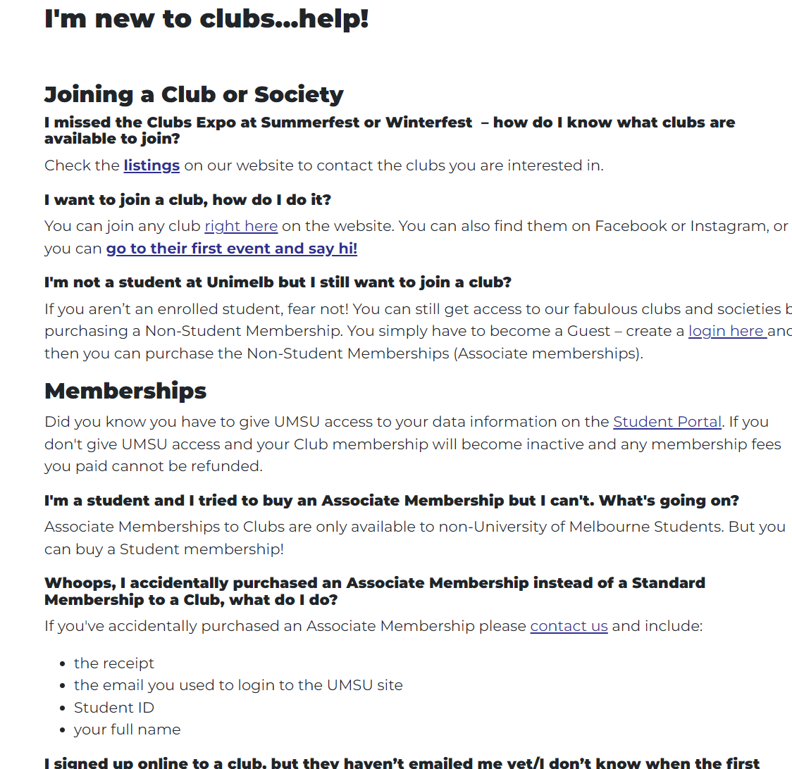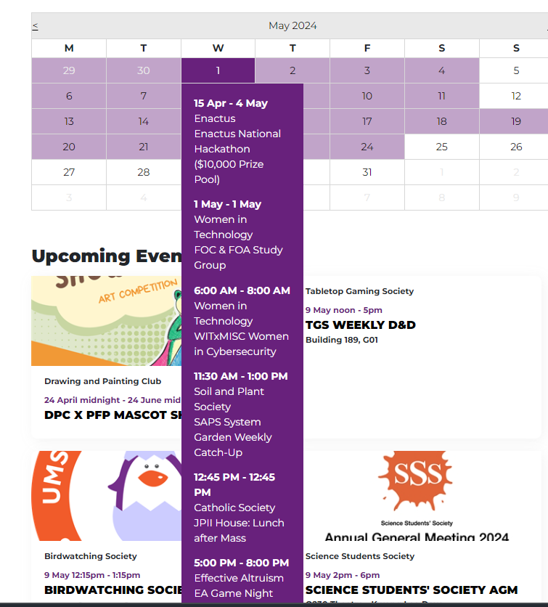Whilst the calendar of events is a great feature on the website, the tooltip that appears when you hover over a date features way too much information and as a result covers other parts of the screen. This increases both kinematic and cognitive load as users are forced to scroll down excessively to view information, and they are also forced to excessively focus to understand what events are occurring on the day due to the abundance of information.
* Several violations of Fitt’s law, for example, “sign in” button is too small, the side menu is also too small.

**Potential Features for our website.**

* The calendar is potentially a good feature, provided that it is optimized for cognitive/kinematic load.
* The site utilizes breadcrumbs to show the user which part of the website the user is in.
* Input assistance to let users know when they have forgotten to enter something in an input field.

**Website #2:** <https://www.dosomething.org/us>

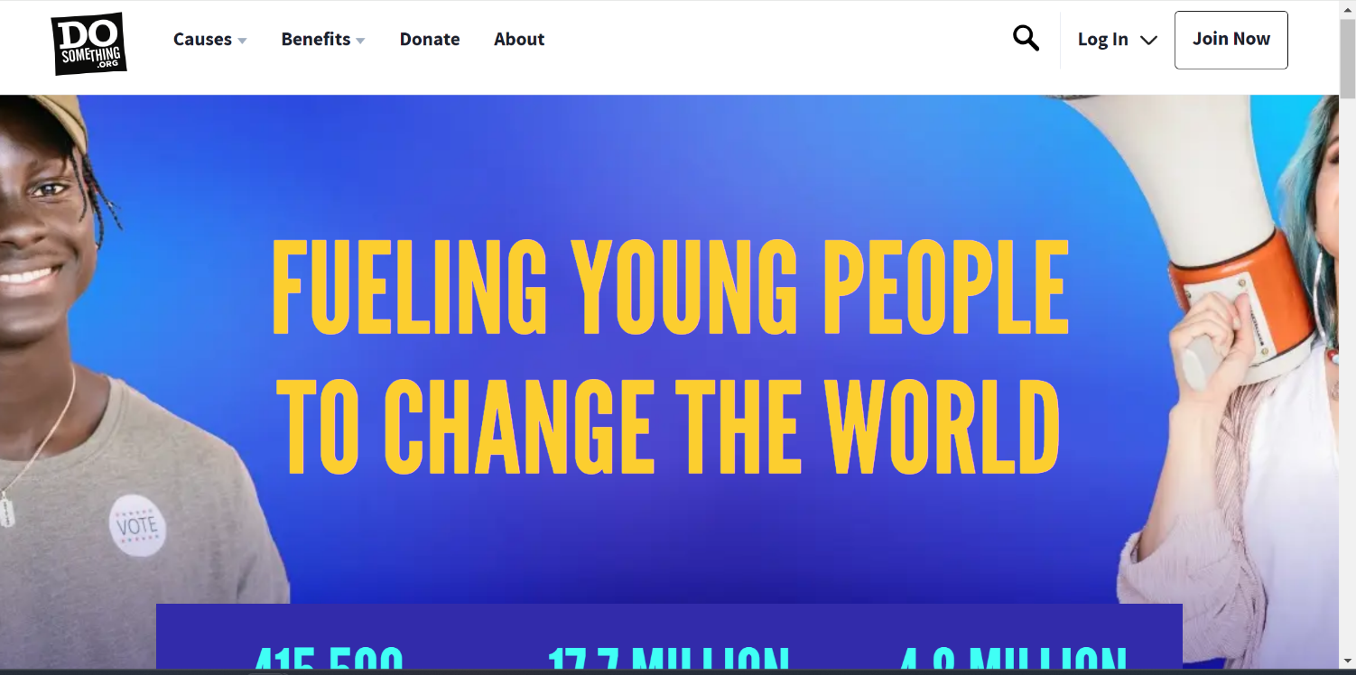The next website chosen for analysis was doSomeThing, which is an organization that aims to inspire and engage young people to create positive change in the world.

**Parts that work well:**

* The website features a very intuitive and visually appealing interface.
* Relatively simple, uncluttered user interface with a consistent layout that reduces cognitive load. Effective use of color also reduces kinematic load.
* Big buttons and relevant elements being close together also help reduce cognitive load.
* Main page of website features big, bold, yellow text to instantly captivate the viewer’s attention.
* Most images have alt text. It also uses colors with good contrast, which makes the content easy to read. The text is clear, a good font, and has a high contrast ratio and is a reasonable size.
* The website features a navigation bar of a reasonable size for easy navigation.
* The website uses multiple different Sans-Serif fonts for optimal readability.

**Parts that don’t work well:**

* Scaling on the website appears to be incorrect, on some pages the background image gets cut off on the right and left sides.
* Important components of the website, such as the “Log in” and “Join Now” buttons are not emphasized enough to capture the user’s attention.
* There are some issues with how the website handles zooming in and out, certain images completely disappear. Mobile compatibility?

**Potential Features to include:**

* Banner at the top for easy navigation across the website.
* Emphasizing certain buttons of the website to capture the user’s attention

**Website #3:** [**https://www.kayavolunteer.com**](https://www.kayavolunteer.com)

The next website that was analyzed was Kaya, which is a volunteering organization.

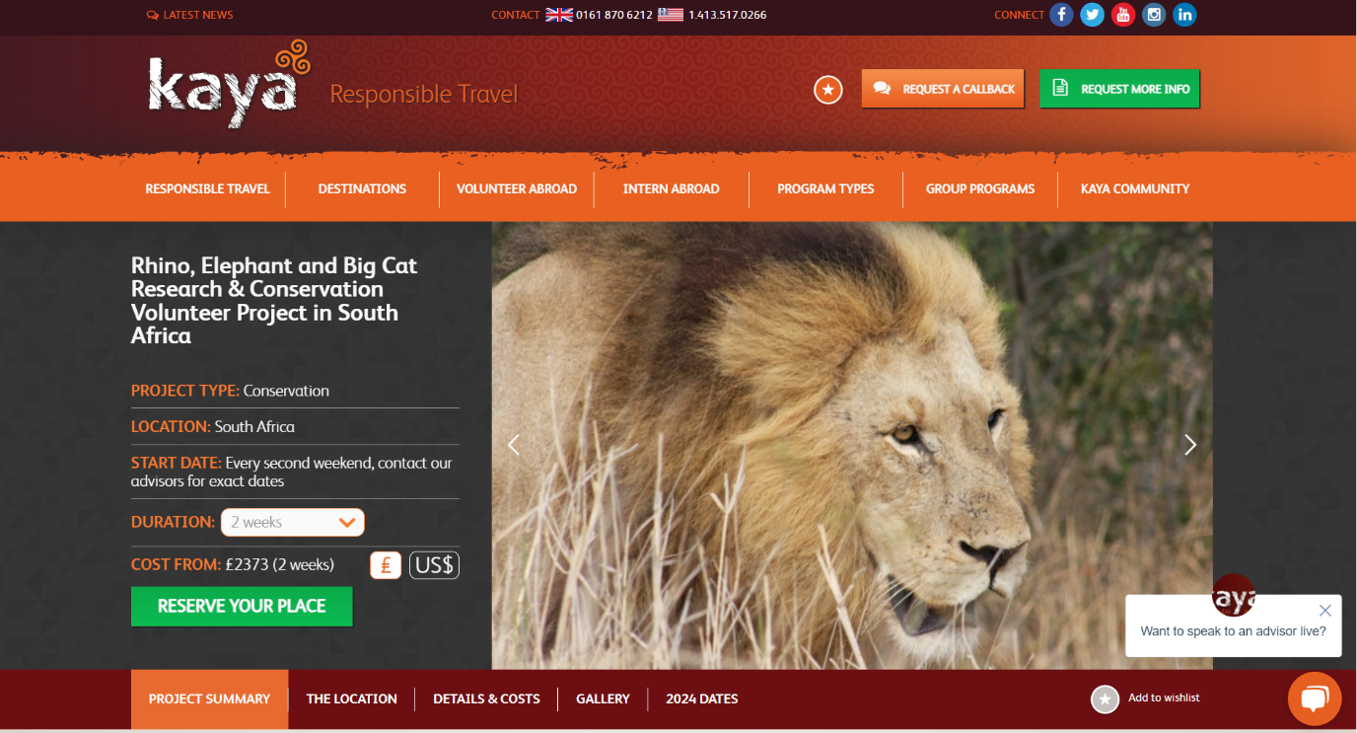

**Parts that work well:**

* The event/announcement is the first thing that shows up along with an image, this captures the user’s attention.
* Several buttons on the website are of a color that stands out, encouraging users to click it.
* Uses color quite effectively to reduce cognitive load.
* Key headings are boldened to make the information more digestible.
* For the most part, zooming in on the website is handled well, the main navigation banner to turns into a hamburger icon with a dropdown menu.

**Parts that don’t work well:**

* There are too many options and too much information on every page, the website is quite cluttered which increases the cognitive load.
* Some minor zooming in issues such as white space that appears when webpage is zoomed in enough.
* 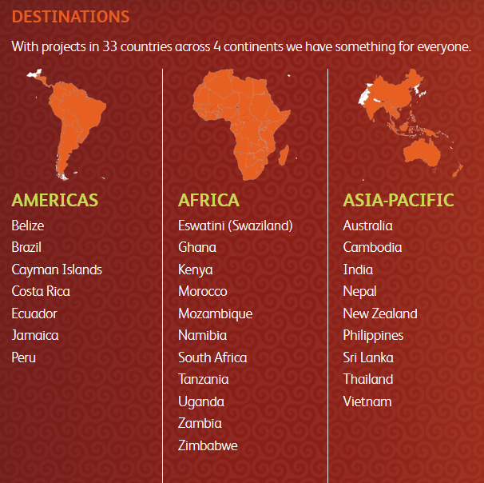The maps are split into different continents, and although it’s helpful that you can focus on what you need, it would be better if the map was interactive as this would increase the quality of the website, encouraging users to interact with it.
* Uses the star icon to represent a wishlist, however it is not immediately obvious to the average user what this star represents.

**Parts to include in website:**

* The map is potentially a good feature for the website, provided that the map is made interactive and not split into different continents.
* The use of the hamburger style menu may be something to keep in mind when accounting for different screen sizes.

**Website #4:** [**https://www.impactplus.com/services/schedule-now**](https://www.impactplus.com/services/schedule-now)

This website that was analyzed is for a Impact, which is a company that specializes in sales and marketing training.

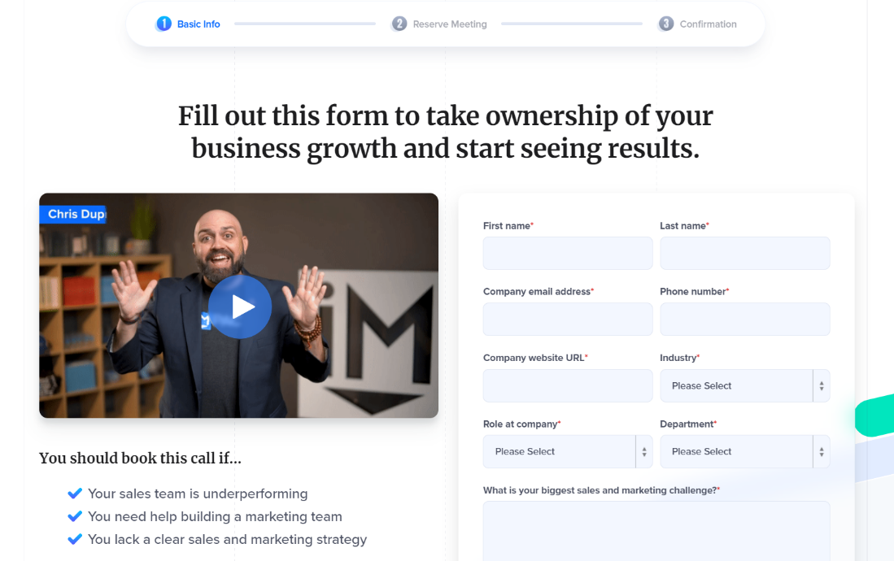

**Parts that work well:**

* The Book Your free coaching Session button is highlighted encouraging users to click it.
* The talk to us page is very clean and simplistic, uncluttered, and only has features that are relevant to the user.
* Additional options such as FAQs only show when user scrolls, which is good as this means the user is looking for additional information.
* The booking process is split up into individual parts, instead of one large chunk of information, which reduces cognitive load.
* The website utilises the ideal amount of colour to instantly hook the user in and keep them engaged.
* Important features in the website such as the quote at the start and the FAQs are boldened to capture the viewer’s attention.
* It also uses colors with good contrast, and the text is clear and easy to read, is a good font has high contrast ratio and is an appropriate size. All Text is appropriately spaced.
* Zooming in on the website to make the font size bigger does not break the website, the layout stays consistent.
* The website features input assistance to help users avoid mistakes and when filling in a form, notifies the user that not all fields have been filled in.

**Parts that don’t work well:**

* They ask for too much information, some of which may not be necessary for the current function.
* The video has a gif-like thumbnail which constantly moves and distracts the user from filling in the form.

**Parts to include in Website:**

* The use of colour in the website is fantastic, as well as various small yet effective visual elements such as the card behind the input fields and the rounding of input fields.

Website #5: <https://foodcycle.org.uk/>

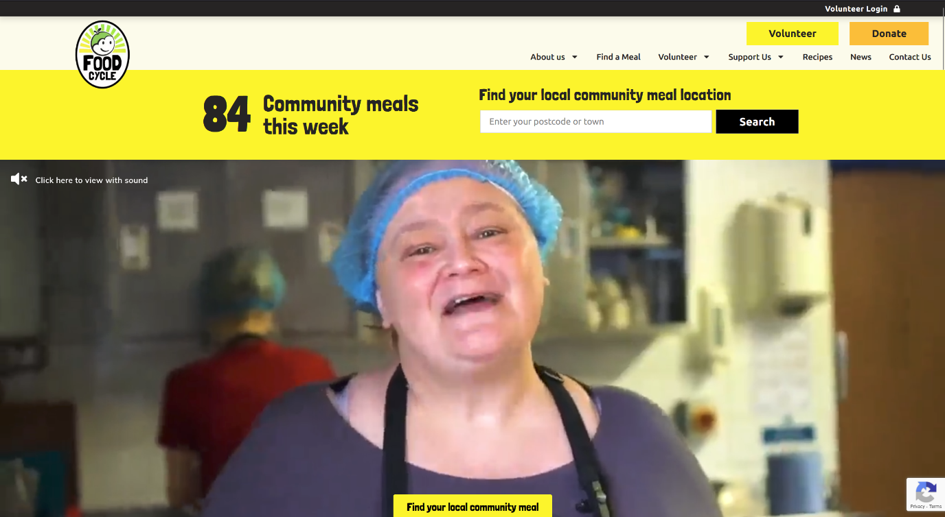

This website is for the FoodCycle organization in the UK, which aims to reduce food poverty and connect communities.

**Parts that work well:**

* The home page features a large autoplay video which immediately captures audience attention and informs them about the organization
* Autoplay video is muted by default so that users are given the option to watch the video with sound – users that are revisiting the page are therefore not required to mute the video every time, reducing kinematic load
* Watching the video with audio provides the user with playback options to easily tweak volume
* When expanding an FAQ to read the answer, any previously expanded FAQ is automatically minimized so that the user is not required to scroll the page
* Hyperlinks in text are very apparent as they are colored bright orange to contrast with normal text
* The “Find your local community meal” tab, being an especially important page, is fixed to the bottom of the screen such that the user will always be able to navigate to this page from any point on the home page
* To reduce cognitive load, the home page features visually appealing icons specifically under the “What We Do” heading, so that the user can sufficiently infer information at a glance

**Parts that don’t work well:**

* The exit button for closing the video on the home page is dark grey on a black background making it exceedingly difficult to see especially on low brightness settings or for users with vision impairments
* The Login button is too discrete, and attention is drawn instead to the buttons below that are larger and more colorful
* The buttons are very inconsistently designed, which can lead to increased cognitive load – many different button colors, some buttons change color when hovered over while some do not

**Parts to include in website:**

* The idea of the “Find your local community meal” tab being visible on all pages is something that could be incorporated into the website, perhaps in the form of a navigation banner.

Website #6: <https://www.mealsonwheelssa.org.au/>

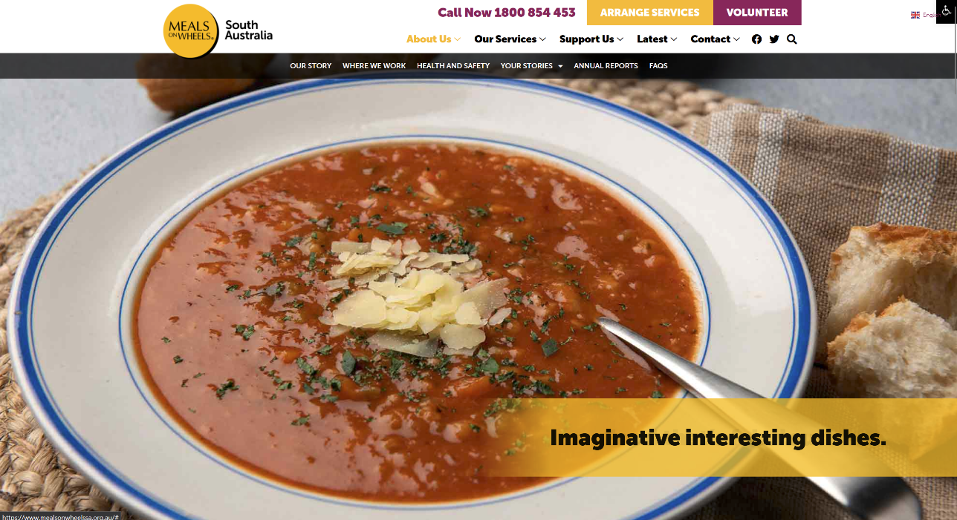

This webpage is from Meals on Wheels in South Australia, which aims to provide support through meal delivery to help members of the community to be independent

**Parts that work well:**

* The webpage provides accessibility to the user both in the form of language options and accessibility tools which allow the user to incrementally scale all text sizes and use high contrast mode
* A “To Top” button is provided at the bottom of each page which will take the user back to the top of the page without requiring a scroll input, largely reducing kinetic load
* The “Arrange Services” and “Volunteer” buttons at the top of the page are both a very noticeably different color such that even though they are directly adjacent, the user can easily distinguish where one button ends and the other begins

**Parts that don’t work well:**

* The dropdown menus for the tabs at the top of the page create a new row of child tabs below instead of a standard dropdown. The standard reaction of moving the cursor directly to the desired tab will often result in a trajectory that overlaps another parent tab option, opening a different dropdown. More cognitive effort is required to avoid opening another dropdown, which would otherwise not be required in a normal dropdown menu.
* The new row of dropdown tabs is too thin, and as such it is too easy for the user to leave the row bounds which will close the dropdown and require the user to reopen it. For users on trackpad or high sensitivity, a greater effort is required to navigate these dropdowns.
* The language options and accessibility options are overlapping on default page zoom, and thus trying to click one option may open the other – the accessibility options could be made more accessible

**Parts to include in website:**

* The back to top and accessibility button may be a useful feature to enhance user experience.

## Web Application Design

Initial Website Design (Desktop)

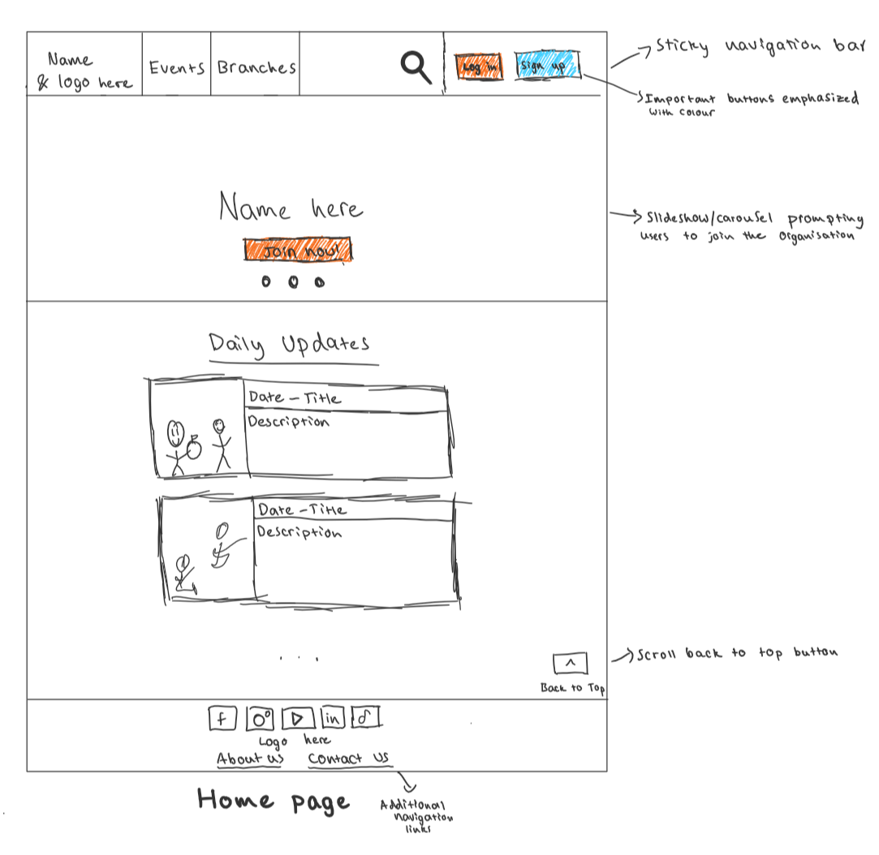

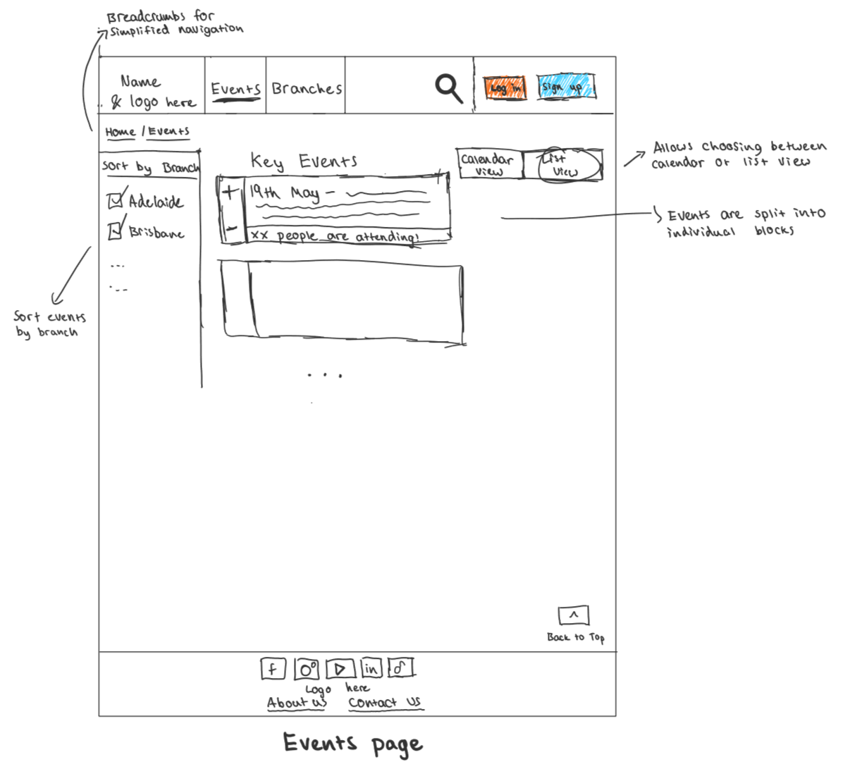

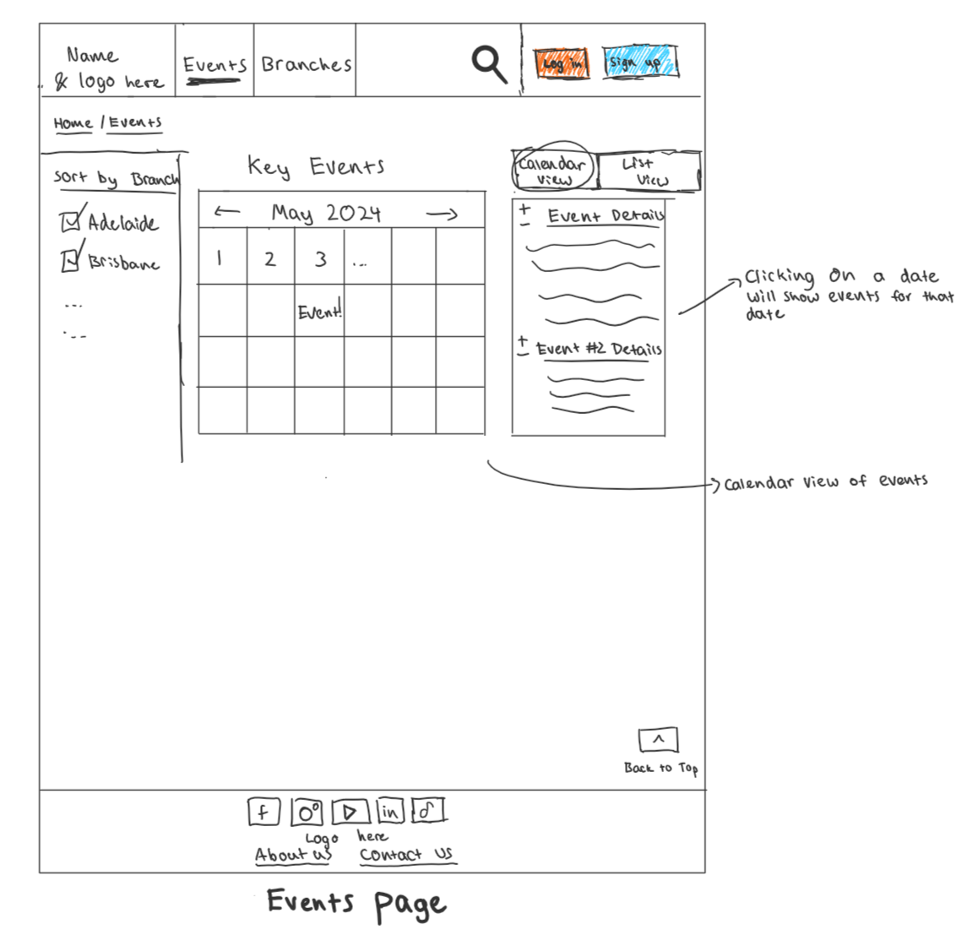

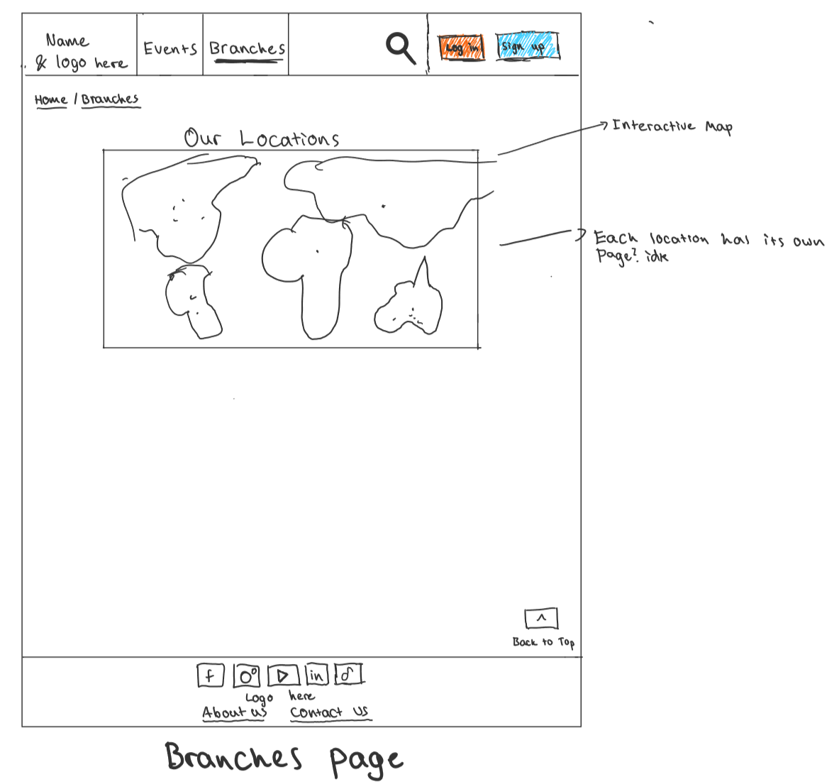

The design of the website features a large sticky navigation bar at the top, with two tabs to allow the user to easily access the “Events” and “Branches” pages, a search bar, as well as a sign up and a login button, specifically emphasized with colours to captivate the user’s attention. The website also features a back to top button that appears when the user starts scrolling downwards. The bottom of the page features a minimalistic and accessible footer with social media links and the organization’s logo. This footer also has additional links for the About Us and Contact Us pages (which act as a safety net, and act as secondary buttons)

The home page offers a clear hierarchy into how the website is structured. The top of the home page has a slideshow/carousel of different images, prompting the user to join the organization and featuring the site identity and what its about. There is also a large, coloured join now button to encourage the user to join the organization. Below this, there is a daily updates section which features articles, events and a summary of any important things occurring on that day which gets updated daily. Overall, the design of the homepage effectively follows the UX design principle of what a home page should accommodate.

The centre of the events page displays upcoming events in a clearly organized and intuitive manner. The page is organized into event blocks, with each block displaying information about the event, including the name, date and time. This approach reduces cognitive load, as it makes it easy to scan through and find events which the user may be interested in. Each event block has coloured plus and minus buttons that can be used to register interest in the event, and there is a small banner at the bottom of each event to let the user know how many people are attending. Furthermore, the left section of the website allows the user to filter the results by the branch of the organization, which helps optimize the user experience by reducing clutter. Users may also be interested in seeing these events in a calendar view, which is why there is also an option on the page to switch to calendar view. The calendar will display the current date as well as any future events. Clicking on an event will …. // ADD STUFF HERE

The branches page features a large interactive map showing all of the organization’s branches. The users can click on a location on the map to view additional information. // ADD STUFF HERE This approach reduces the cognitive load of the website by encouraging users to interacting with the map.

The dimensions for the layout of the website are designed with flexibility in mind. As such, certain elements such as the header and footer will maintain a fixed size, whilst content areas such as the calendar and the key events section as well as text and images will be able to stretch/adjust to accommodate varying screen sizes. This resizability and scalability is further discussed in the mobile website design below.

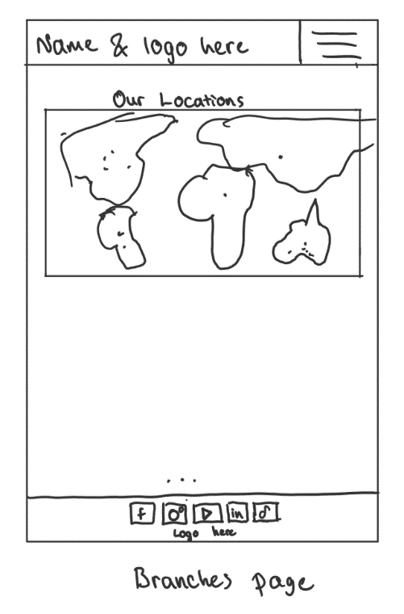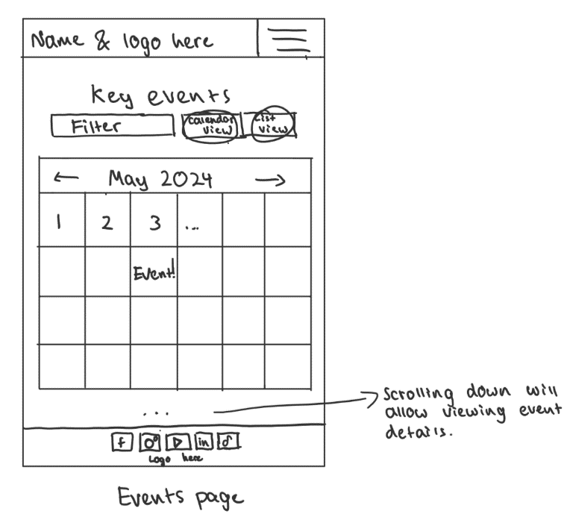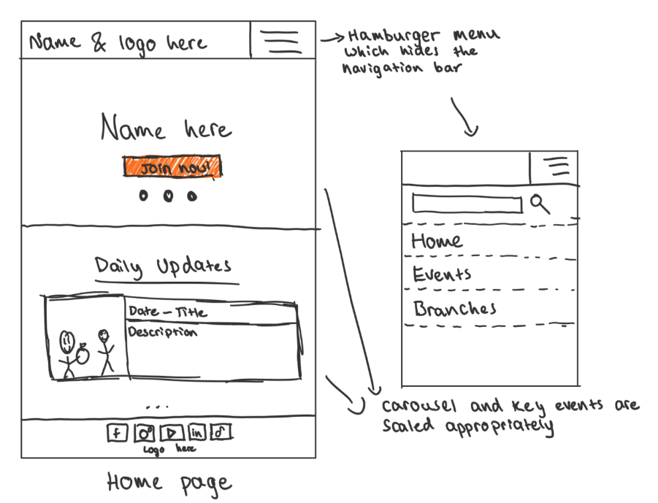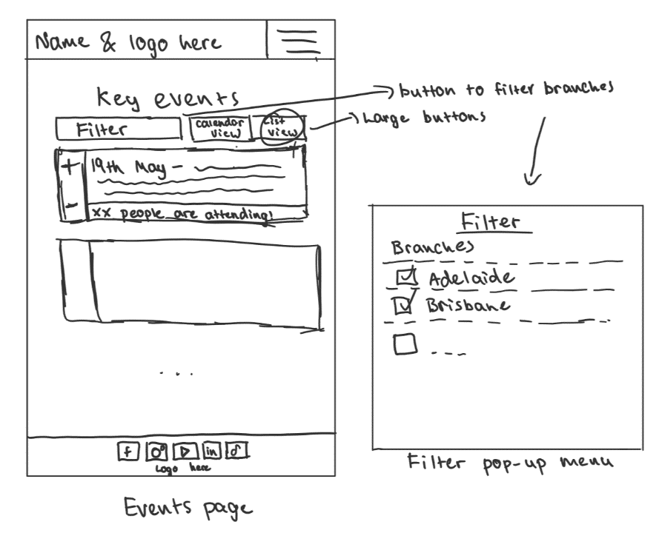Initial Website Design (Mobile)

The mobile design will retain many of the key features of the desktop version whilst modifying some features to ensure easy navigation and accessibility and reduce clutter, and that the entire screen space is utilized effectively.

The home page features a simplified navigation banner, with the navigation banner condensing into a single row. Tapping the hamburger icon on the right reveals the “Branches”, “Events”, search bar and Login/Sign up links in a dropdown menu. This approach reduces the cognitive load by reducing visual clutter. Content areas such as the daily updates and carousel also scale appropriately, with buttons and frequently interacted with features being relatively larger to ease navigation and minimize the need for precise gestures.

The layout of the Events page has been restructured to better accommodate mobile devices. The top of the page has three buttons, Filter, Calendar View and List View. Clicking the filter button will open user-friendly pop-up menu, with large easily tappable buttons to allow users to filter the events by branch. The calendar view of the Events page has a large calendar that now fills up the screen. Clicking on a date will… // ADD STUFF HERE

The structure of the Branches page remains quite similar to the desktop version, with the map and all elements appropriate scaled. Intuitive interactions catered towards mobile users are also present, such as pinch-to-zoom for the map feature, enhancing user engagement while minimizing cognitive effort.

* Dimensions on design?
* These features will utilize relative size.

## Features:

1. Main page carousel

Inspiration: This feature is a combination of University of Melbourne’s website’s banner and the event that can be seen on the Kaya’s Volunteering website

Where: On the home page

User Interaction: It will be a slideshow/carousel of different images prompting the user to join the organization as well as a description of the organization. There will also be a join now button.

Result of interaction: The join now button will redirect the users to a separate join now page and the carousel will allow users to view …. (something). // ADD STUFF HERE

1. Calendar

Inspiration: University of Melbourne’s event page  
Where: Events page on the website  
User Interaction: The user can see the events in the form of a calendar. Upon clicking on an event either a tooltip can appear that shows additional information about the event, or additional information can appear to the side of the calendar. The user will then be able to register their interest.  
Result of interaction: If the user hovers over the event, they are shown additional information. If they click on it, they are taken to a page where they can register for the event (Alternatively it can all be done on the same page?) // ADD STUFF HERE

1. Navigation Banner

Inspiration: doSomeThing  
Where: At the top of the page  
User Interaction: The user will be able to see three main options: home, events and branches, along with a search bar. On the right hand side of the banner there will be log in and signup buttons.   
Result of interaction: If the user clicks on home, event or branches, they are taken to the page where they can view the respective information. If they type in something in the search bar, they can find events or branches related to their search query, and clicking log in or sign up takes them to the respective page, where they can log in or signup.

1. Emphasized action buttons

Inspiration: doSomeThing and Kaya Volunteering, Impact Plus  
Where: On action buttons such as log in, sign up, join the organization, register for an event.   
User Interaction: The user will see buttons that capture their attention using specific design choices, prompting them to make that action by clicking the button.  
Result of interaction: When the user clicks on a button, they will be taken to the page where they can log in, sign up, join the organization, register for an event etc.

1. Interactive map

Inspiration: From the separated map on Kaya volunteering, we decided that the kinematic load will be reduced, and users would be encouraged to interact with the website if the map was interactive.

Where: On the branches page  
User Interaction: The user can see a map of all the locations of the organization. The user can hover/click on locations where a branch is located.   
Result of interaction: The user hovering on the branch shows additional information such as the address and members etc. Clicking on the branch will take the user to a page that shows more details about the branch. // ADD STUFF HERE

1. Talk to us/Contact Us button

Inspiration: Impact plus  
Where: On the footer  
User Interaction: User can see the talk to us button (it will be made to capture user’s attention) and can click on it.  
Result of interaction: When the user clicks on the button they are taken to the contact us page. // ADD STUFF HERE

1. Talk to us page

Inspiration: Impact plus  
Where: Contact us page  
User Interaction: User can type in the information that is required to set up a meeting, including their name, phone number and email. They can press the continue button after entering the information. If the user scrolls down text pops up showing common reasons for booking a meeting or a call which will help the user decide whether or not they need the meeting. If they scroll further they can see a set of FAQs.   
Result of interaction: When the user types in their information and clicks continue, they are sent an email outlining details of the meeting. Scrolling down shows texts with common reasons, scrolling down further shows FAQs. Clicking on the FAQs shows the answer to them. // ADD STUFF HERE

1. Accessibility features

Inspiration: Meals on wheels SA  
Where: All over website (button to change features is located on the top right corner of the page)  
User Interaction: User can see different accessibility options by clicking the button. They can view and toggle the features on or off.   
Result of interaction: When the user clicks on the button, a small window pops up with some accessibility features such as languages, text sizes, colours etc. If the user toggles an option on, that effect is reflected all over the website, if the user toggles an option off, the changes are reverted to their original state. // ADD STUFF HERE

1. To Top button

Inspiration: Meals on wheels SA  
Where: when user scrolls down on any page, a button will appear in the bottom right corner.  
User Interaction: User can click on the button.   
Result of interaction: If the user clicks on the button, we take the user back to the top of the page without requiring any scroll input and the button disappears.

1. Breadcrumbs

Inspiration: University of Melbourne website  
Where: Underneath banner at the top of page  
User Interaction: User can see where they are on the website and click any of the pages in the breadcrumbs.  
Result of interaction: When the user clicks on a page, they are taken back to that page.

## Design Review

Next, the design was reviewed and tested against usability heuristics as well as kinematic and cognitive load. The usability heuristics that were discussed included Operable, Perceivable, Understandable, and Robust.

**Perceivable:**

* **Adaptable Content:** Content on the website is adaptable and specifically designed to be able to accommodate various screen sizes.
* **Distinguishable:** Text is clear, a reasonable size and spacing, and has good contrast. Colours have good contrast, which has been verified using <https://colorsafe.co/>. There are hover items in the design which violates this principle, however it is justified as on smaller screens, hover items and pop-up menus can be important as they include additional information or functionality without cluttering the interface, which can significantly improve the user experience for users on mobile devices.

**Operable:**

* **Enough time:** The website does not have any timed interactions.
* **Seizures and Flashing Content:** High contrast or flashing content is not present in the website.
* **Navigable –** The simplistic design of the website makes it highly navigable through the use of a sticky navigation banner and breadcrumbs to let the user the know where they are on the webpage.
* **Input Modalities –** The website is designed to easily accommodate a variety of input methods such as touch or pointer methods through the use of mobile-friendly features such as large buttons. The website also follows key parts of Fitts’ law, in the sense that interactive elements, such as buttons and links are sufficiently large and easily accessible and common buttons such as login and sign up are easily reachable.

**Understandable:**

* **Readable:** All text content on the webpage is readable and understandable, text will also be appropriately scaled on various screen sizes.
* **Predictable:** The website adheres to commonly recognized conventions for feature placement. For instance, the login button is situated in the top-right corner of the screen, while the logo occupies the top-left corner, and the search bar is at the top of the screen.
* **Input Assistance:** Input fields in the website will include input assistance to let the user know when they make a mistake or if they haven’t filled in a field in.

**Robust:**

* **Compatible:** The way in which the website is designed means that there are not elements that might be challenging to implement consistently across different browsers and devices. As well as this, there are no design choices that may become outdated quickly, and the website is future proof.

**Kinematic and Cognitive Load:**

The current design of the website has several features that reduce kinematic and cognitive load to optimize the user experience. For example:

* The website’s layout strategically positions frequently used features in easily accessible and perceivable spots. For example, the log in and sign up buttons, as well as the search bar is positioned in places easily accessible to the user, making the user not have to use additional mental effort to find these features.
* The website also uses a consistent style and layout, which further reduces cognitive load.
* The website avoids clutter by providing appropriate spacing between elements, and does not overload the user with information.
* The website uses common, every-day language to avoid having users to think exert additional mental effort and to make it easy to understand what that part of the page is doing. Examples include “Key Events” and “Sort By”, etc.
* The use of the sticky navigation banner means that most of the website’s controls are within easy reach, which reduces the amount of physical effort required to navigate the site.
* Buttons which may be frequently used are made larger to make it easier to interact with them.
* Information is broken down on the website into smaller, digestible chunks. For example, the events and announcements on the page each have their own block which makes information easier to scan and understand, reducing cognitive load.
* The simplistic design of the website means that there is very little kinematic load on the end user. There are no excessive/extraneous actions present and navigating across the website is intuitive and accessible.

However, there are a few modifications which could be made to further improve kinematic and cognitive load.

* The current lack of visual design and colour causes an increased cognitive load on the user, which can potentially make it difficult to navigate the website and lead to decreased engagement. It may be worth implementing additional colour to the website to address this issue and make it more visually appealing in general.
* Whilst there are some icons present on the website (such as the magnifying glass for search), in general the website lacks icons which may lead to increased cognitive load. This is because without the visual cues provided by icons, users must use additional mental effort to process and comprehend textual labels.
* Currently the events and main page have all of the events viewable at once. This may overwhelm users with too much content at once which is why it may be worth using techniques such as a “read more” button to reveal additional details only when users express interest, thus minimizing cognitive load.

As well as this, we requested that another group review our design. The group discussed the following:

* The website appears to be quite easy to navigate, we really like the use of the sticky navigation bar, as well as the use of the scroll up buttons to enhance the user experience.
* The use of colour for important buttons is also effective in drawing the user’s attention. However, you may want to add in even more colour to make the website more appealing, as currently the website looks a bit plain. This would also help reduce cognitive load on the user!
* You may want to have the list view/calendar view/refine buttons altogether to reduce kinematic load and make the website a little more navigable, having them so far apart seems a bit counterintuitive.

To address this feedback and the previous analysis of the website, we changed the design of the website and implemented the following features:

* Adjusted the location of the list view/calendar view buttons and moved them above the sort by branch section. These features are likely to be used together frequently, hence it makes sense to position them close to one another. This change also means that the kinematic load of the website is reduced.
* A read more button was implemented on the home page and the Events Page to reveal additional details only when users express interest and click the button, thus minimizing cognitive load.
* An important part of the website that was changed was the use of colour. Colour was added to several important buttons which users will likely be using often, the navigation banner, the footer, and events/announcements. Subheadings were also boldened, which makes them easy to identify and provides a clear structure for the content.

### Final Design

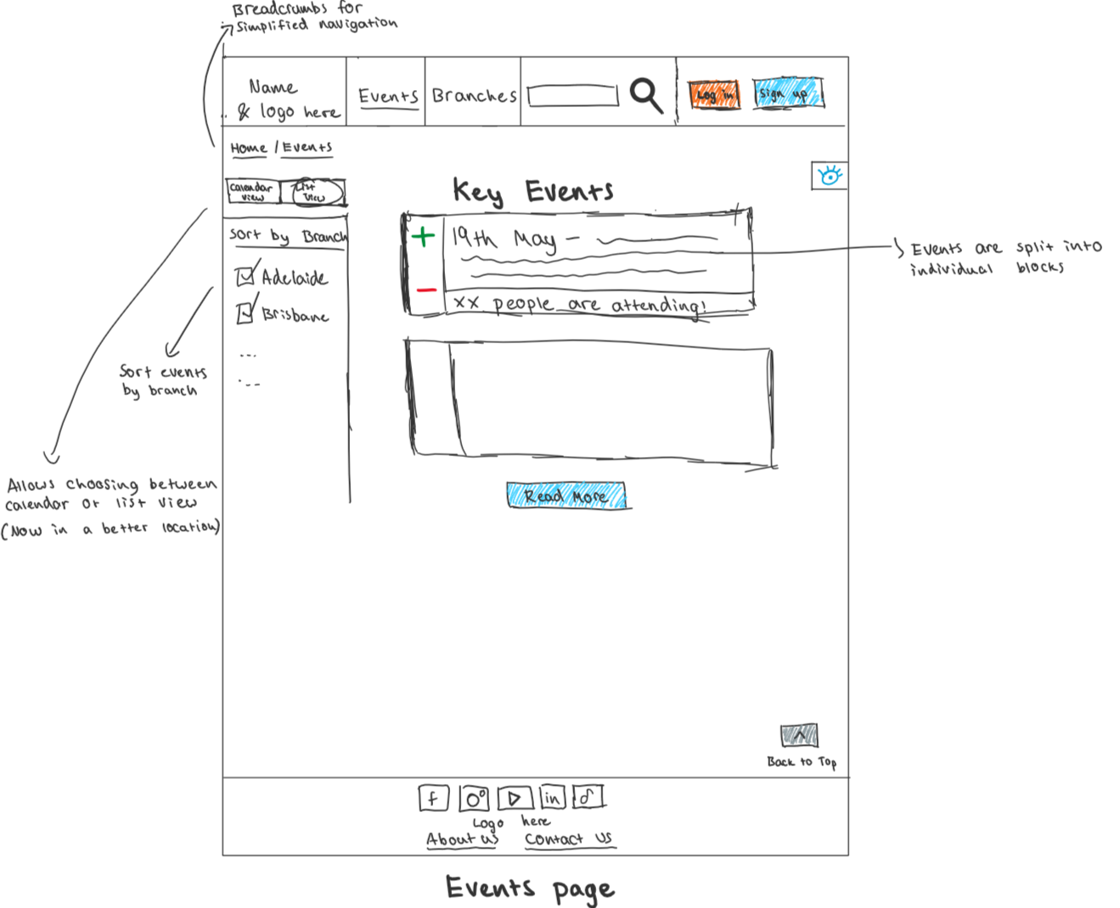

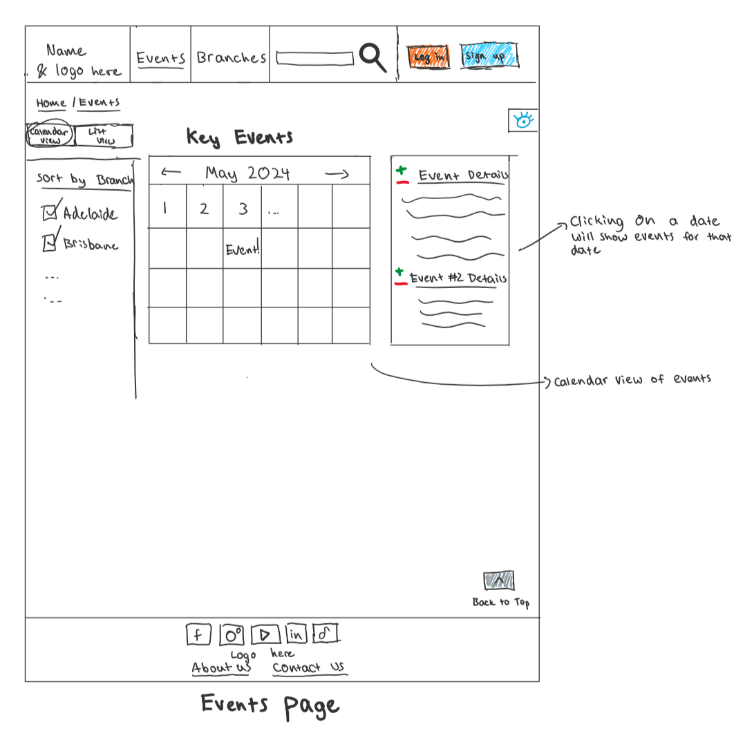

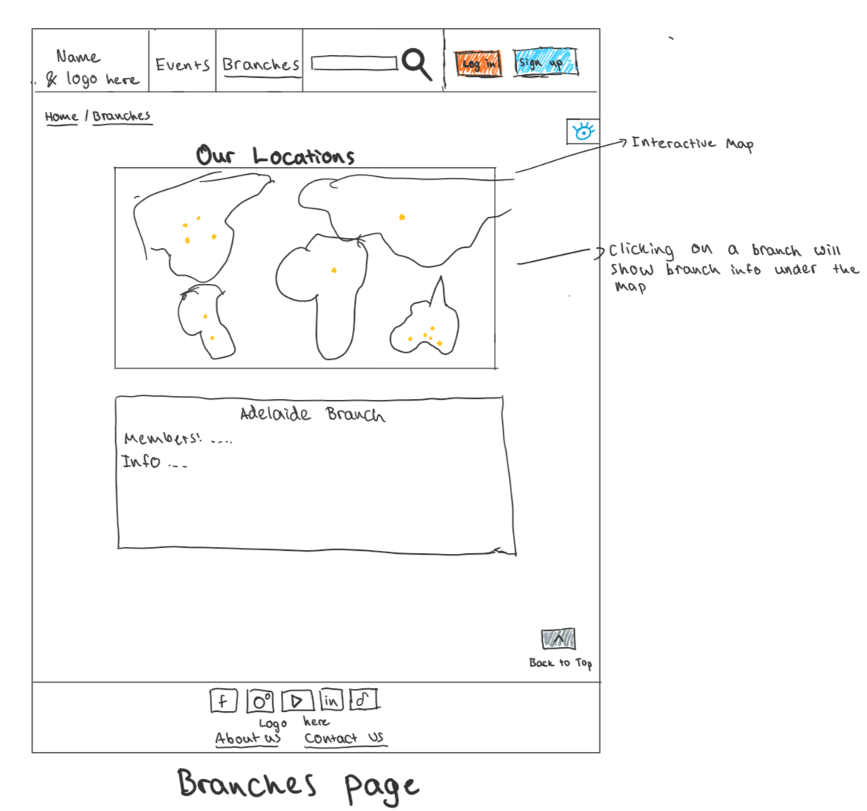

### Data Plan

See repo

### Database Schema

Note that for the schema we have made the following assumptions:

* Each user has a unique email
* Events and updates are related to the organisations
* Only managers can create/update posts and events
* Only admins can manage users and organisations

See repo

### Website HTML/CSS

### 